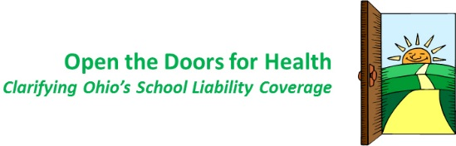

Case Study: Schools as the Center of the Community
Note: Innovative school districts, such as the one in this case study, have opened their facilities to the community to address both students’ and the communities’ need for recreational activity spaces through shared use agreements. However, many schools are hesitant to open their schools due to liability concerns. Here in Ohio we are working to raise awareness of the need to clarify liability laws in our state so that more schools will open their doors and gates more widely.
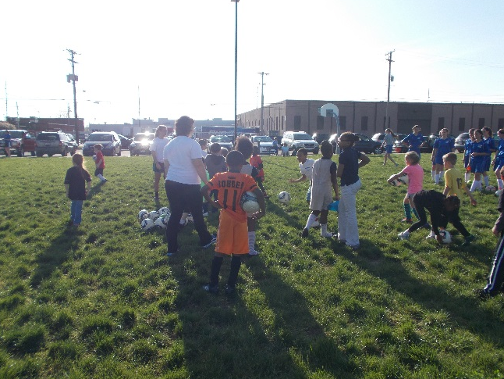
Who: Dayton Public Schools
What: Neighborhood School Centers
When: Since 2006
Where: Montgomery County, Ohio
Why: To bring together community members, local organizations and businesses to provide opportunities and services for the public utilizing school facilities as a community hub.
Teresa Wendell is passionate about her job as a site coordinator for the Neighborhood School Centers project with Dayton Public Schools, and she recognizes the significance of her day-to-day work for the school and the community. In her full-time role at Kiser PreK-8 School in urban Dayton, Wendell brings school administrators and educators together with community members, local organizations and businesses to provide opportunities and services for the public, utilizing school facilities as a community hub. She builds relationships, makes connections, and engages the community.
“Several years ago when the school district wanted to pass a levy, this project was a commitment from the school district to the citizens of Dayton that neighborhood schools would be available for community usage. There are five neighborhood schools and everybody kind of does their own thing depending on the unique needs to support the individual neighborhoods.”
Dayton Public Schools has been intentional about its commitment to support these five urban communities with a focus on expanding shared use of all school facilities. For the past eight years, each of the five neighborhood schools has had a site coordinator stationed in the building working with the district and many outside partners to reimagine the role of the neighborhood school as the hub in the community. The result is more connected communities, a litany of programs that benefit the well-being of kids and adults, and a flexible approach to utilizing school facilities in productive ways after school hours.
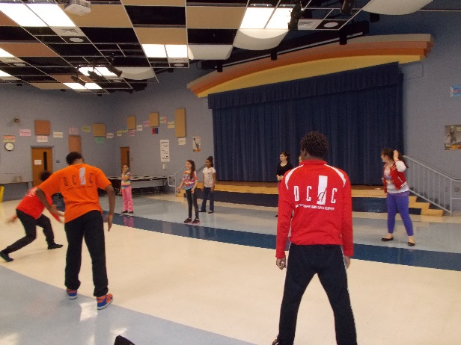
Key project partners are Montgomery County, City of Dayton, United Way, and the Fitz Center for Leadership in Community—all of which provide some program guidance, administration and funding. Major funding sources and individual school partners includes a long list of Dayton organizations that are all committed to helping revitalize community schools. Each center is anchored with one or two key partnerships with organizations such as the Salvation Army, East-End Community Services, Good Samaritan Hospital and the YMCA of Greater Dayton. This formula seems to be working, noted Wendell, but it’s the flexibility to nurture and grow any appropriate partnerships that gives the program real potential. “Each partner has strengths and weaknesses,” she said, “and each community has different needs. The hope is to identify the needs, and find the best partners and programs.”
Shared use of recreational facilities and programs that target kid’s health and fitness is a critical component of the community center vision. One success story at Kiser Elementary is a partnership with the Greater Dayton YMCA and the United States Soccer Foundation. This program brings together sport and nutrition with a kid-friendly and engaging approach. “It’s a 12-week program in the fall and the spring, which utilizes nutrition sciences using soccer as the hook. So, for example, one soccer session will be about dairy and we’ll talk about milk, but the activity will use the soccer ball with a game called milking the cow.”
Another impactful program is the weekly ‘Family Café’ produced in partnership with a local church that focuses on tutoring for children and ESL training for adults. This type of engagement is key, according to Wendell, as it increases parent involvement and creates an environment where she can introduce other services. “This is the time that we educate our parents on healthy foods, the importance of wellness and physical fitness, and why immunizations are important. It’s just one of these cool things where the planets line up and everything moves forward.”
For Wendell, success cannot only be measured by the amount of programs produced and the number of participants. The real impact is in seeing the community come together and move forward with a united mindset—and having one interaction go full circle and show itself down the road in individual, family and community improvement. Providing access to facilities and programs that support good health and self-improvement plants a seed, she adds, and so much progress is made when people are given the opportunity to come together, participate and make connections. As Wendell and the other site coordinators learn about the community, the community learns about itself as a collective unit, and the school becomes a place that brings it all together. “It’s amazing to see the springboard take shape into other things,” said Wendell. “What we do becomes this amazing organic growth.”
If you’re committed to expanding shared use of school recreational facilities in your community and all around Ohio, please show your support today. You can learn more about the Neighborhood School Centers pilot on the Dayton Public Schools website.

